*Florida International University*

*School of Computing and Information Sciences*

CIS 4911 - Senior Capstone Project

Software Engineering Focus

Feature Document

User Story # 629

**Team Member:**

Garrett Lemieux

**Product Owner(s)**:

Francisco Ortega

**Mentor(s)**:

Francisco Ortega

**Instructor**: Masoud Sadjadi

**User Story - disable gestures while drawing**

* As a User I would like to be able to draw using leap motion without gestures being observed in order to prevent accidental mode changes.
* **Acceptance Criteria**:

1. User must be able to draw and not change modes accidentally with a Leap Motion gesture.

**Use Case: User draws with leap motion and gestures disabled**

User wants to be able to draw without having to worry about accidently performing a leap gesture.

* Details:
* Actor:
  + User
* Pre-conditions:
  + TouchPoint app is running.
  + Leap Motion is running.
* Description:
  + Use case begins when User has decided to draw a using the leap motion.
  + User begins to draw and gestures are disabled while he or she draws using leap motion and no gestures can be detected by leap motion.
* Post-conditions:
  + The User experiences no change in current mode setting for color, shapes being drawn, or an image was not saved.
* Decision Support:
  + Frequency: High, User must be able to draw without triggering a motion being read by leap motion.
  + Criticality: High, In order for User to draw his or her own images and have a smooth experience, gestures changing modes must not be detected.
  + Risk: Medium, Had to figure out how disable gestures frame by frame.
* Usability:
  + Need to understand how the leap motion draw works as a User
  + When in the hover zone gestures can be read while drawing no gestures are detected.
* Reliability
  + High
* Performance
  + Performance: High
  + Failure: Low
* Supportability
  + Leap Motion Device
* Modification History:
  + Owner: Garrett Lemieux
  + Initiation Date 3/03/2016
  + Date last Modified: 5/4/2016

**Use Case Diagram**

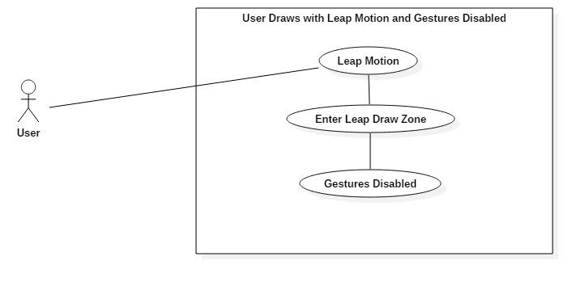

**Sequence Diagram**

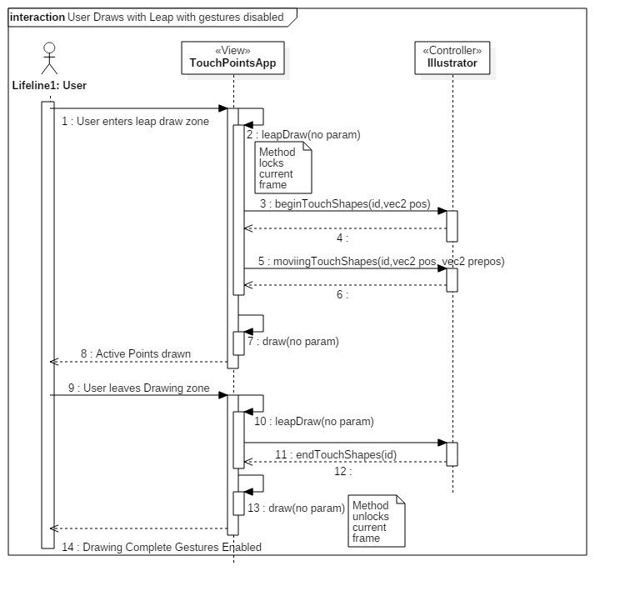

**Class Diagram**

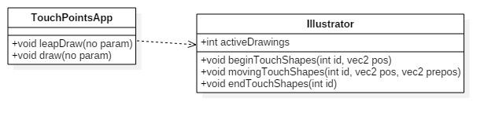

**Unit Test**

* Sunny Day Test:
  + **Test Case  - Circle gesture not detected while drawing**
    - Test Purpose: To determine if the circle gesture is disabled while a user is drawing using the leap motion device.
    - Test Procedure: User enters drawing zone with index finger and begins to draw using leap motion. He or she then draws circles in different parts of the canvas.
    - Expected Results: The User should expect to see circles drawn in correct locations.  User should also see no change in the current drawing settings throughout test.
  + **Test Case  - Swipe gesture not detected while drawing**
    - Test Purpose: To determine if the swipe gesture is disabled while a user is drawing using the leap motion device.
    - Test Procedure: User enters drawing zone with index finger and begins to draw using leap motion. He or she then draws vertical and horizontal straight lines in different parts of the canvas.
    - Expected Results: The User should expect to see vertical and horizontal lines drawn to correct locations.  User should also see no change in the current drawing settings throughout test.
  + **Test Case  - Keyboard tap gesture not detected while drawing**
    - Test Purpose: To determine if the keyboard tap gesture is disabled while a user is drawing using the leap motion device.
    - Test Procedure: User enters drawing zone with index finger and begins to draw using leap motion. He or she then performs keyboard tap gestures.
    - Expected Results: The User should observe no change in the applications settings.
  + **Test Case  - Screen tap gesture not detected while drawing**
    - Test Purpose: To determine if the screen tap gesture is disabled while a user is drawing using the leap motion device.
    - Test Procedure: User enters drawing zone with index finger and begins to draw using leap motion. He or she then performs screen tap gestures.
    - Expected Results: The User should observe no change in the applications settings.
* Rainy Day Test:
  + **Test Case  - User begins to draw attempts to perform  circle gesture while still in drawing zone**
    - Test Purpose: To determine user can perform circle gesture while in drawing zone.
    - Test Procedure: User enters drawing zone with index finger and begins to draw using leap motion. He or she then decided to perform a circle gesture while still in drawing zone.
    - Expected Results: The User would expect to see a change to the current setting of the application, but no change in the system would occur.
  + **Test Case  - User begins to draw attempts to perform swipe gesture while still in drawing zone**
    - Test Purpose: To determine user can perform swipe gesture while in drawing zone.
    - Test Procedure: User enters drawing zone with index finger and begins to draw using leap motion. He or she then decided to perform a swipe gesture while still in drawing zone.
    - Expected Results: The User would expect to see a change to the current setting of the application, but no change in the system would occur.
  + **Test Case  - User begins to draw attempts to perform keyboard tap gesture while still in drawing zone**
    - Test Purpose: To determine user can perform keyboard tap gesture while in drawing zone.
    - Test Procedure: User enters drawing zone with index finger and begins to draw using leap motion. He or she then decided to perform a keyboard tap gesture while still in drawing zone.
    - Expected Results: The User would expect to see a change to the current setting of the application, but no change in the system would occur.
  + **Test Case  - User begins to draw attempts to perform screen tap gesture while still in drawing zone**
    - Test Purpose: To determine user can perform screen tap gesture while in drawing zone.
    - Test Procedure: User enters drawing zone with index finger and begins to draw using leap motion. He or she then decided to perform a screen tap gesture while still in drawing zone.
    - Expected Results: The User would expect to see a change to the current setting of the application, but no change in the system would occur.

**Integration Testing**

* The disabling of gesture recognition has been added to application and does not affect the other devices and their functionality.
* TouchPointsApp still has full functionality with both devices.

**User Guide**

* User can perform any hand gesture when finger is in hover zone which is displayed with a green circle. Once user has entered hover zone and moves towards screen the moment the green circle disappears no more hand gesture can be read.
* User will be provided hand gesture once he or she leaves the draw zone or exits the leaps filled of vision.